1. 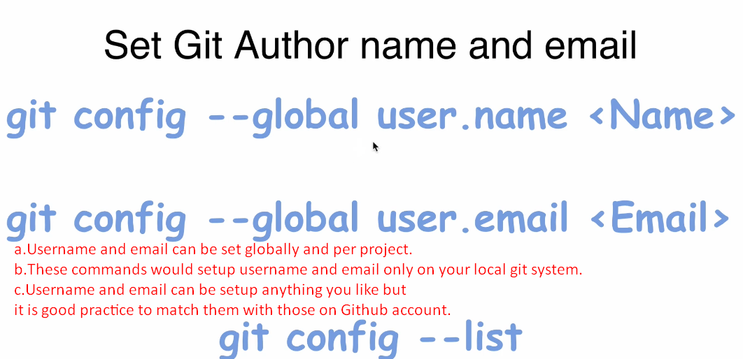
2. 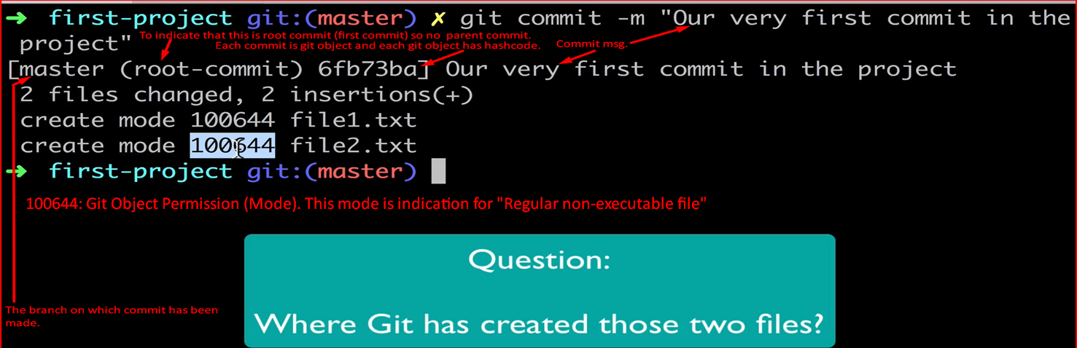
3. 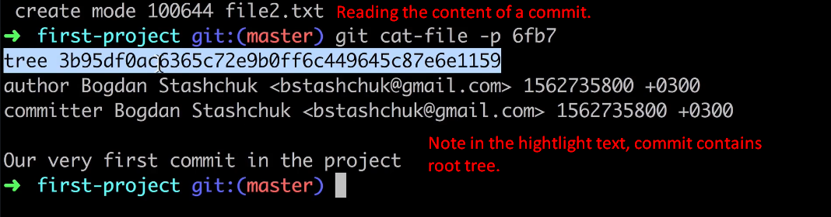
4. 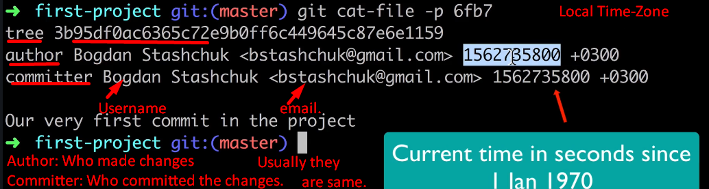
5. 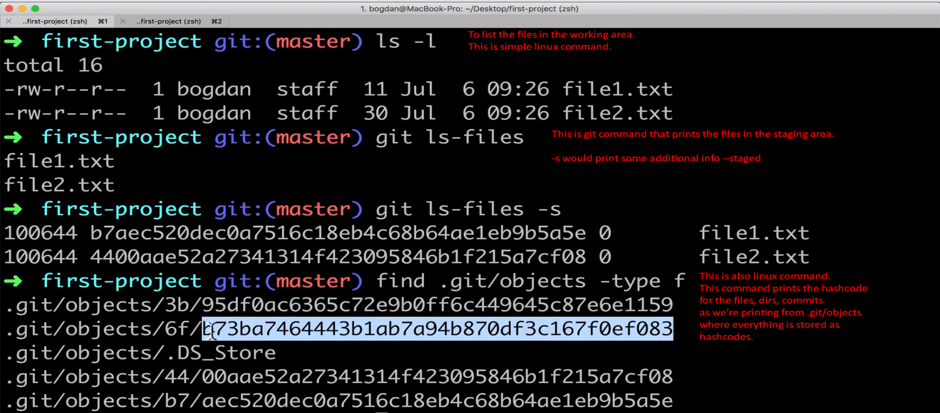
6. 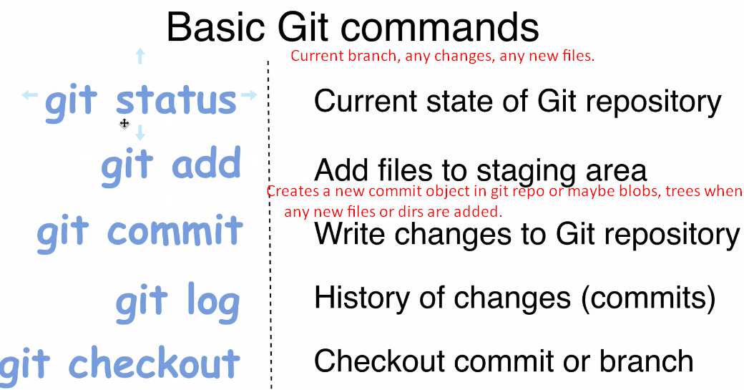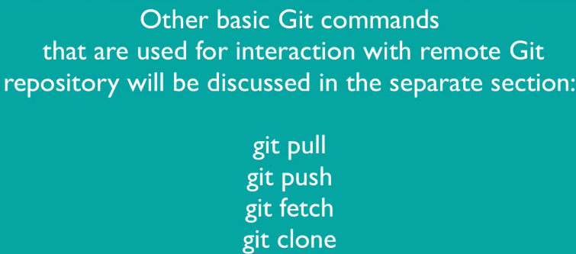
7. Git status
8. git log
9. nano filename.extension
   1. To create a new file or update the existing file.
10. **git add**:

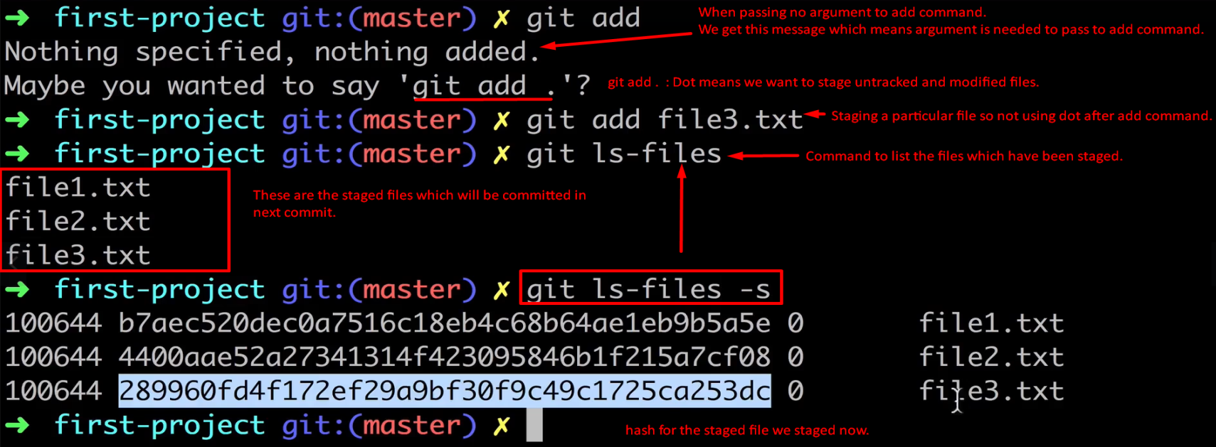

1. git rm --cached <file_path> 🡸 To unstage a staged file.  
   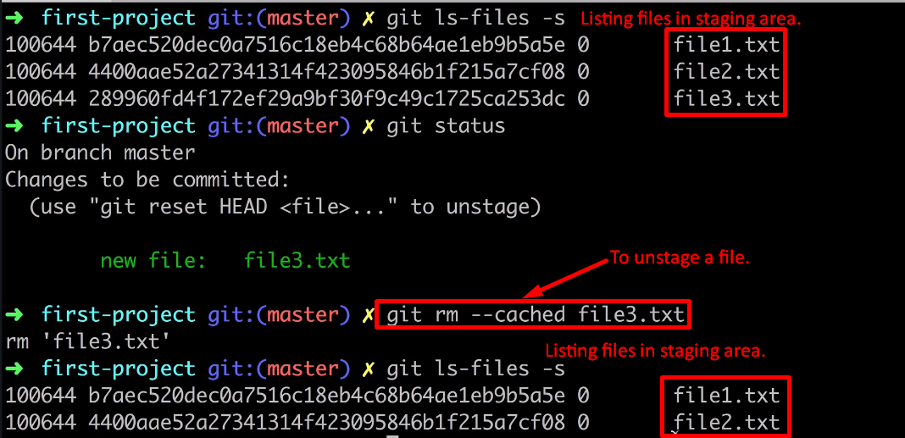
2. git commit:  
   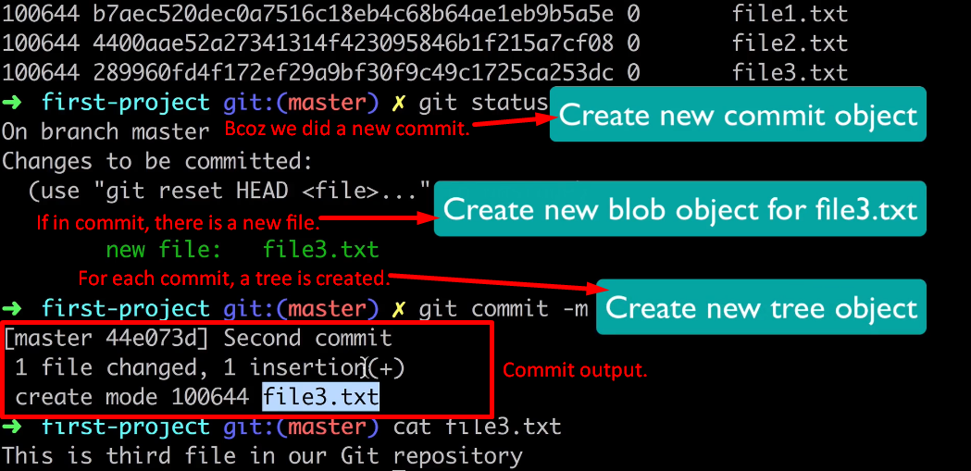
3. git cat-file <commit_id>  
   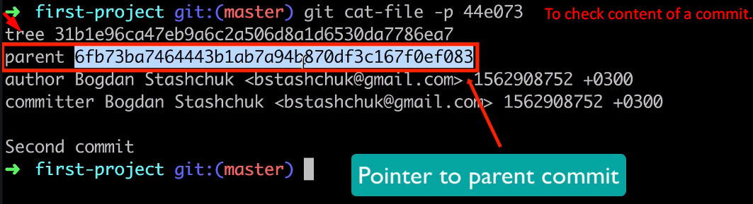
4. 